**Supplementary Material**

# SPM 1: Study context: drought and conflict in Somalia

In Somalia, drought events are well-known, reoccurring extreme weather phenomena. Somalia’s population faces recurring extreme weather events and conflicts, disrupting existing migration and pastoralism routes. Where poverty prevails, the resilience of the population is severely affected by compounding vulnerabilities (Marthews et al., 2019; Thalheimer et al., 2021), illustrating a diverse set of internal displacement drivers. At the same time, the country has a well-established war economy (Shortland et al., 2013). Impacts from extreme weather events on human wellbeing and livelihoods are further exacerbated by the absence of a central government coupled with poverty and civil conflict that can escalate to crisis-level food insecurity and large-scale displacement. In the context of climate change impacts, the 2016/17 drought has not been explicitly influenced by anthropogenic climate change (van Oldenborgh et al., 2017). Given the high number of affected people and high levels of vulnerability, 2017 records the highest drought-reported displacement: 892,000 IDPs. After the 2016/17 drought across Somalia, extreme precipitation during the *Gu* rain season in 2018 led to episodes of flash floods and an additional 274,000 IDPs reporting flood as their primary reason for displacement. According to the internal displacement data used in this analysis (UNHCR Somalia, 2017), the share of the drought affected IDP households is more than two times larger than those reporting conflict as primary displacement reason. The survey data provides clear evidence that both drought and conflict drive internal displacement, however, the magnitude of these effects is unknown. Models 1-5 in the main text provide estimates of the marginal effects of temperature and precipitation anomalies, as well as conflict events on displacement.

**References for SPM 1**

Marthews, T.R., Jones, R.G., Dadson, S.J., Otto, F.E.L., Mitchell, D., Guillod, B.P., Allen, M.R., 2019. The Impact of Human-Induced Climate Change on Regional Drought in the Horn of Africa. Journal of Geophysical Research: Atmospheres 124, 4549–4566. https://doi.org/10.1029/2018JD030085

Shortland, A., Christopoulou, K., Makatsoris, C., 2013. War and famine, peace and light? The economic dynamics of conflict in Somalia 1993–2009. Journal of Peace Research 50, 545–561. https://doi.org/10.1177/0022343313492991

Thalheimer, L., Gaupp, F., Webersik, C., 2021. Compound vulnerabilities exacerbate systemic risks of food security in Somalia (preprint). In Review. https://doi.org/10.21203/rs.3.rs-893022/v1

UNHCR Somalia, 2017. Protection & Return Monitoring Network (PRMN) - Notes on methodology.

van Oldenborgh, G.J., Philip, S., Cullen, H., Singh, R., van Aalst, M., Otto, F.E.L., Kimutai, J., 2017. Rapid analysis of drought in Somalia, 2016.

# SPM 2: Additional Tables and Estimation Results

In the main part of the paper, we measure the effects of extreme weather on internal displacement and violent conflict on internal displacement. Here, we provide an overview on the summary statistics (Table SPM 2.1) and all model results (Tables SPM 2.2-2.5). We add a brief analysis on the effect of violent conflict on total displacement (Table SPM 2.3) which refers to channel B of the conceptual framework (Figure 2 in the main text). We also show the estimation results of the effects of conflict on displacement when controlling for weather in SPM Figure 2.1. We also report the estimation results of displacement on conflict when controlling for weather in SPM Figure 2.2. We report the estimates of conflict intensity (proxied by conflict fatalities instead of conflict events) in Figures SPM 2.3 and SPM 2.4.

*Table SPM 2.1: Summary Statistics*

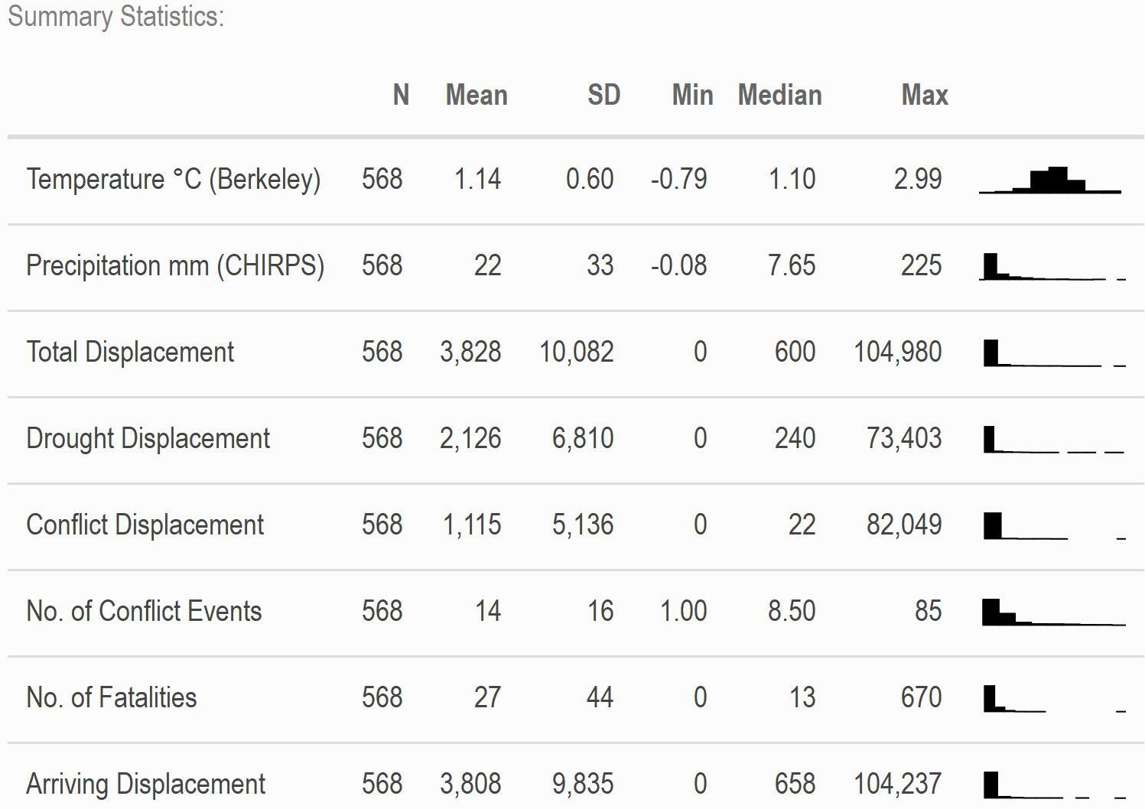

Here, we report the full regression estimates from Models 1-5 (main text). Effect plots in the main text (Figures 3-6) are derived by combining the estimated impacts over temporal lags (forming a linear combination). Estimated uncertainties are derived using the estimated variance of the cumulative effects (taking covariances of lagged effects into account). Standard errors are clustered at the region level (admin level 1).

*Table SPM 2.2: Regression results Part 1.*

|  |  |  |
| --- | --- | --- |
|  | **(1) Total Displacement** | **(2) Drought Displacement** |
| Temperature | -0.05308 | 0.09369 |
|  | (0.56768) | (0.39249) |
| Precipitation | -0.00425 | -0.01032 |
|  | (0.00734) | (0.00833) |
| L1.Temperature | -0.98954 | -0.11719 |
|  | (0.67271) | (0.38226) |
| L1.Precipitation | -0.00344 | -0.00653 |
|  | (0.00964) | (0.00780) |
| L2.Temperature | -0.37252 | 0.54494 |
|  | (0.34052) | (0.46803) |
| L2.Precipitation | -0.01347 | -0.00728 |
|  | (0.00929) | (0.00943) |
| L3.Temperature | 0.97473** | -0.16089 |
|  | (0.43412) | (0.35774) |
| L3.Precipitation | -0.00881 | -0.01073** |
|  | (0.00508) | (0.00475) |
| L4.Temperature | 0.01656 | 0.22728 |
|  | (0.49743) | (0.55999) |
| L4.Precipitation | -0.00685 | -0.00965 |
|  | (0.00786) | (0.00656) |
| Temperature^2 | 0.13365 | 0.08237 |
|  | (0.23426) | (0.19282) |
| L1.Temperature^2 | 0.33268 | 0.00631 |
|  | (0.26915) | (0.16882) |
| L2.Temperature^2 | 0.43570** | -0.03193 |
|  | (0.17418) | (0.21452) |
| L3.Temperature^2 | -0.17920 | 0.18246 |
|  | (0.17474) | (0.18337) |
| L4.Temperature^2 | 0.24629* | 0.17041 |
|  | (0.12894) | (0.18277) |
| Precipitation^2 | 0.00000 | 0.00004 |
|  | (0.00004) | (0.00004) |
| L1.Precipitation^2 | -0.00003 | 0.00000 |
|  | (0.00006) | (0.00004) |
| L2.Precipitation^2 | 0.00004 | 0.00001 |
|  | (0.00005) | (0.00004) |
| L3.Precipitation^2 | 0.00005* | 0.00005 |
|  | (0.00002) | (0.00003) |
| L4.Precipitation^2 | 0.00003 | 0.00004 |
|  | (0.00003) | (0.00003) |
| Num.Obs. | 496 | 496 |
| S.E. Type | Cluster-robust | Cluster-robust |
| Fixed Effects | Year & Region | Year & Region |
| * p < 0.1, ** p < 0.05, *** p < 0.01 |  |  |

Notes: N = 568 observations of y total displaced people (1) and of y drought displaced people (2). Includes observations of January 2016 to June 2018.

*Table SPM 2.3: Regression results Part 2.*

|  |  |  |  |  |
| --- | --- | --- | --- | --- |
|  | **(3.1) Total Displacement** | **(3.2) Total Displacement** | **(4.1) Conflict Displacement** | **(4.2) Conflict Displacement** |
| Conflict Events | 0.00143 | 0.02031 | 0.07162** | 0.07055* |
|  | (0.02681) | (0.02881) | (0.03287) | (0.03347) |
| L1.Conflict Events | 0.00963 | 0.01058 | 0.09130*** | 0.09329*** |
|  | (0.01858) | (0.02014) | (0.02262) | (0.02791) |
| L2.Conflict Events | 0.00348 | -0.01106 | 0.01070 | 0.00260 |
|  | (0.01645) | (0.02033) | (0.02028) | (0.02268) |
| L3.Conflict Events | 0.00928 | 0.00850 | 0.03110 | 0.02628 |
|  | (0.01119) | (0.01254) | (0.04345) | (0.05223) |
| L4.Conflict Events | -0.02492 | -0.01909 | 0.01333 | 0.02177 |
|  | (0.01646) | (0.01797) | (0.03120) | (0.03001) |
| Conflict Events^2 | -0.00008 | -0.00027 | -0.00051 | -0.00040 |
|  | (0.00025) | (0.00032) | (0.00033) | (0.00036) |
| L1.Conflict Events^2 | -0.00007 | -0.00014 | -0.00074* | -0.00079** |
|  | (0.00017) | (0.00019) | (0.00026) | (0.00027) |
| L2.Conflict Events^2 | -0.00015 | 0.00001 | -0.00016 | -0.00003 |
|  | (0.00020) | (0.00026) | (0.00020) | (0.00021) |
| L3.Conflict Events^2 | -0.00008 | -0.00019 | -0.00051 | -0.00046 |
|  | (0.00012) | (0.00013) | (0.00039) | (0.00045) |
| L4.Conflict Events^2 | 0.00019 | 0.00017 | -0.00040 | -0.00042 |
|  | (0.00017) | (0.00021) | (0.00032) | (0.00033) |
| Num.Obs. | 514 | 496 | 514 | 496 |
| R2 | 0.965 | 0.968 | 0.819 | 0.824 |
| R2 Adj. | 0.961 | 0.962 | 0.796 | 0.792 |
| S.E. Type | Cluster-robust | Cluster-robust | Cluster-robust | Cluster-robust |
| Fixed Effects | Year & Region | Year & Region | Year & Region | Year & Region |
| Control for Weather Shocks | Yes | Yes | Yes | Yes |
| * p < 0.1, ** p < 0.05, *** p < 0.01 |  |  |  |  |

Notes: N = 568 observations of y total displaced people (3.1 and 3.2) and of y conflict-reported displaced people (4.1 and 4.2). Includes observations of January 2016 to June 2018.

In Supplementary Material SPM 3, we report regressions of conflict on total displacement and conflict-reported displacement with various conflict variables and lags. While disaggregate displacement may be of little interest to measure the real effects of displacement, it is the most simple and transparent variable. This may be reasoned by people reporting truthfully their primary reason for displacement. In contrast, the insignificant coefficient of total displacement may hint to masking in the conflict- displacement relationship.

*Table SPM 2.4: Regression results Part 3.*

|  |  |  |
| --- | --- | --- |
|  | **(5.1) Conflict Events** | **(5.2) Conflict Events** |
| de.displacement | 0.0000024 | 0.0000025 |
|  | (0.0000047) | (0.0000044) |
| L1.de.displacement | -0.0000069 | -0.0000068 |
|  | (0.0000065) | (0.0000063) |
| L2.de.displacement | -0.0000017 | -0.0000009 |
|  | (0.0000048) | (0.0000056) |
| L3.de.displacement | 0.0000101 | 0.0000120* |
|  | (0.0000064) | (0.0000059) |
| L4.de.displacement | 0.0000054 | 0.0000051 |
|  | (0.0000063) | (0.0000067) |
| de.displacement^2 | 0.0000000 | 0.0000000 |
|  | (0.0000000) | (0.0000000) |
| L1.de.displacement^2 | 0.0000000 | 0.0000000 |
|  | (0.0000000) | (0.0000000) |
| L2.de.displacement^2 | 0.0000000 | 0.0000000 |
|  | (0.0000000) | (0.0000000) |
| L3.de.displacement^2 | 0.0000000 | 0.0000000* |
|  | (0.0000000) | (0.0000000) |
| L4.de.displacement^2 | 0.0000000 | 0.0000000 |
|  | (0.0000000) | (0.0000000) |
| Num.Obs. | 514 | 496 |
| R2 | 0.970 | 0.971 |
| R2 Adj. | 0.966 | 0.966 |
| S.E. Type | Cluster-robust | Cluster-robust |
| Fixed Effects | Year & Region | Year & Region |
| Control for Weather Shocks | Yes | Yes |
| * p < 0.1, ** p < 0.05, *** p < 0.01 |  |  |

Notes: N = 568 observations of y conflict events (5.1 and 5.2). Includes observations of January 2016 to June 2018.

*Table SPM 2.5: Marginal Effects of the individual models*

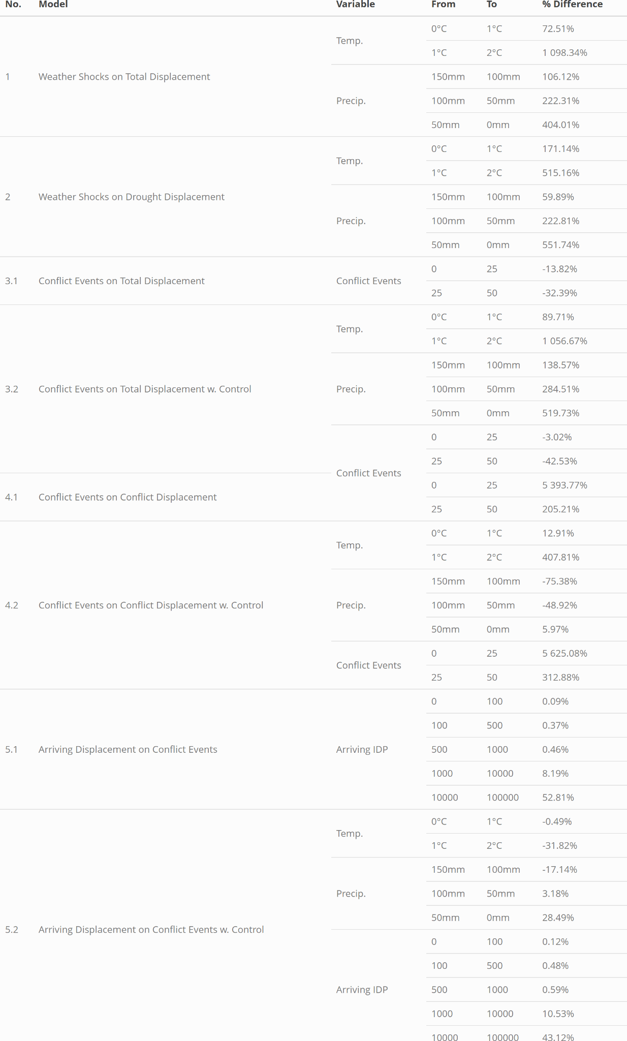

|  |  |
| --- | --- |
|  |  |
| *Figure SPM 2.1: Cumulative non-linear effect of conflict events on total displacement controlling for weather (Model 3.2, left) and conflict displacement controlling for weather (Model 4.2, right). Histogram of conflict events over the sample shown in lower panel.* | |

|  |
| --- |
|  |
| *Figure SPM 2.2: Cumulative effect of arriving displaced people on the conflict events controlling for weather (Model 5.2).* |

|  |  |
| --- | --- |
|  |  |
| *Figure SPM 2.3: Cumulative non-linear effect of conflict fatalities on total displacement without (left) and with (right) controlling for weather. Histogram of conflict fatalities over the sample shown in lower panel.* | |

|  |  |
| --- | --- |
|  |  |
| *Figure SPM 2.4: Cumulative non-linear effect of conflict fatalities on conflict-displacement without (left) and with (right) controlling for weather. Histogram of conflict fatalities over the sample shown in lower panel.* | |

# SPM 3: Robustness to Model Specification

Here we report a series of robustness analyses, varying lag lengths (in SPM 3.1) and restricting our models to linear effects (in SPM 3.2).

# SPM 3.1 Lagged Effects

In the main part of the paper, we measure interaction pathways of weather shocks, conflict events and internal displacement. Here, we assess the robustness to varying the lag length. All these lags may capture different temporal effects of the interaction channels.

First, we decompose the overall effects into the relative contributions of temperatures and precipitation at varying lags (Figures SPM 3.1.1 - SPM 3.1.5). The main drivers of temperature-induced displacement occur at a temporal lag of around 3 months, while precipitation shows significant contemporaneous effects. Second, we plot the estimated effects for models varying the lag lengths from 0 up to 7 months (Figures SPM 3.1.6 - SPM 3.1.7). Overall, results are highly robust to the choice of lag lengths.

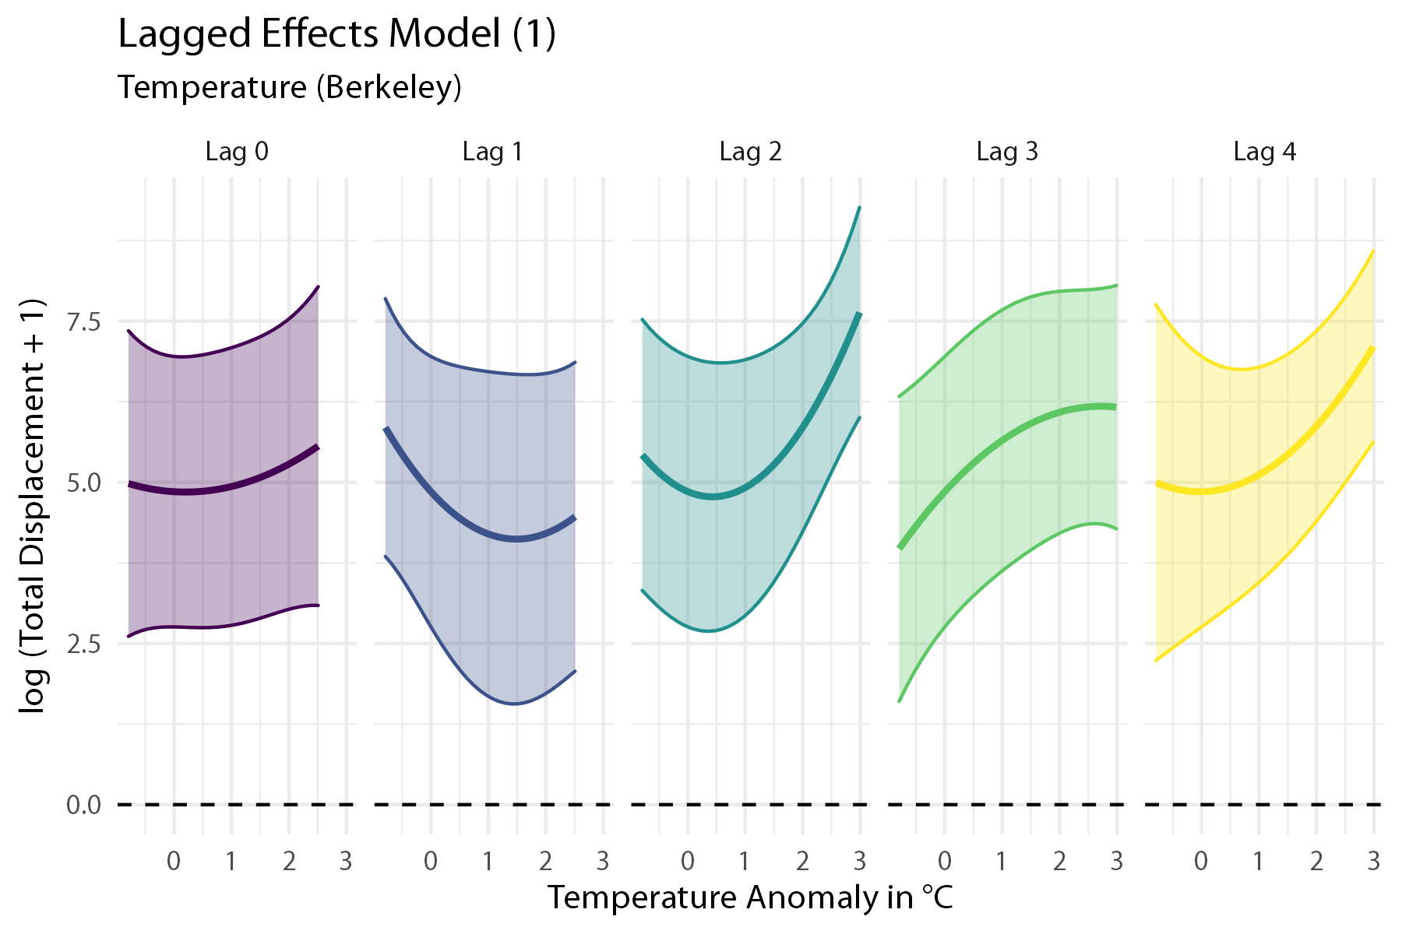

*Figure SPM 3.1.1: Lagged effects of temperature anomalies on internal displacement over 1 to 4 months for Model 1.*

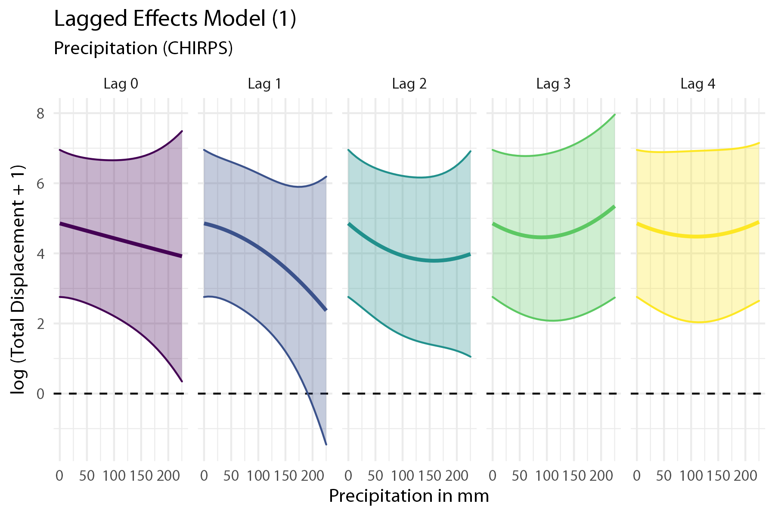

*Figure SPM 3.1.2: Lagged effects of absolute precipitation on internal displacement over 1 to 4 months for Model 1.*

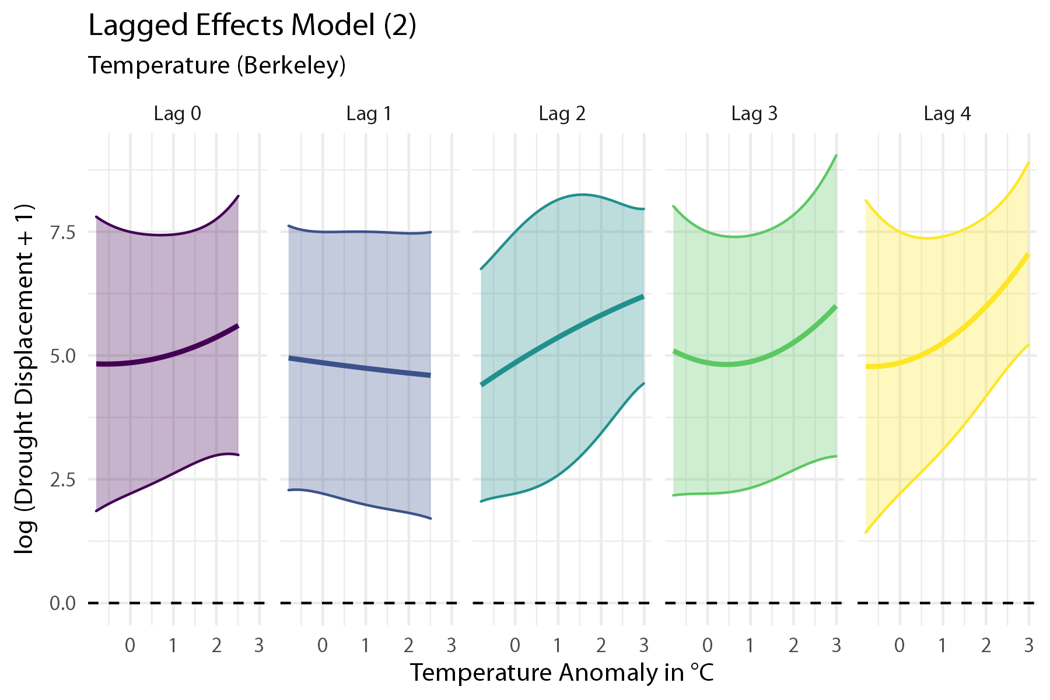

*Figure SPM 3.1.3: Lagged effects of temperature anomalies on internal displacement over 1 to 4 months for Model 2.*

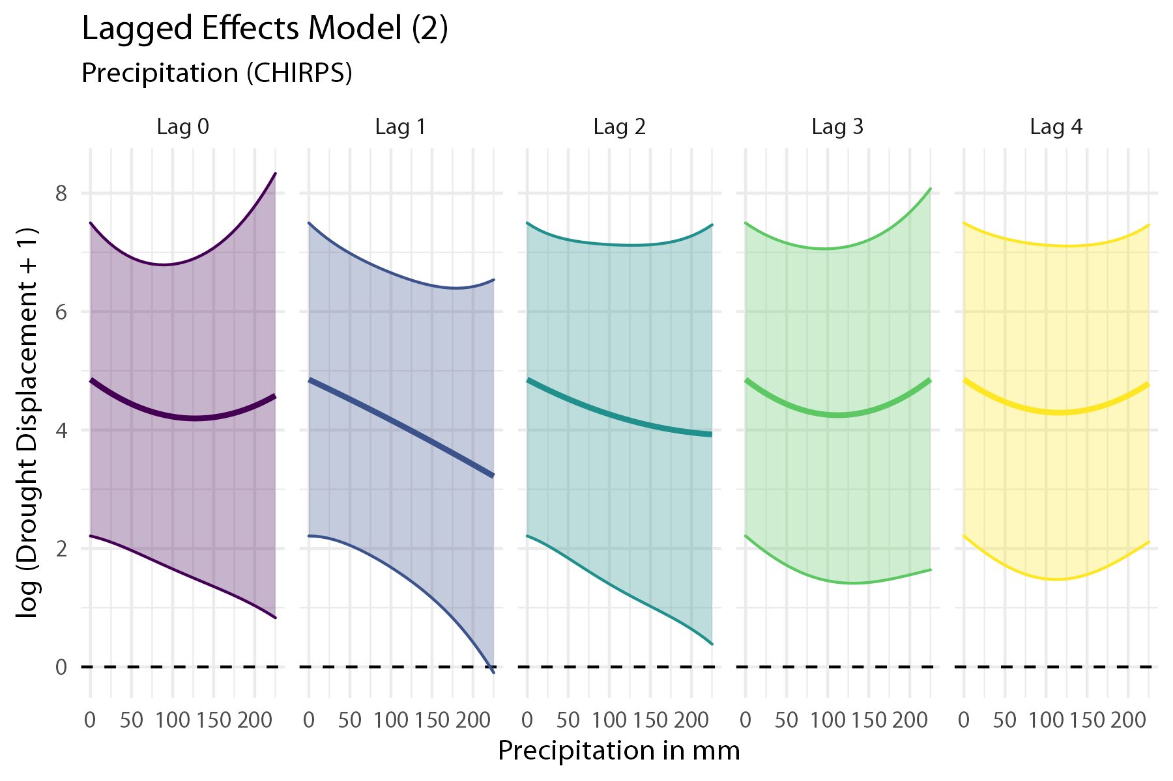

*Figure SPM 3.1.4: Lagged effects of absolute precipitation on internal displacement over 1 to 4 months for Model 2.*

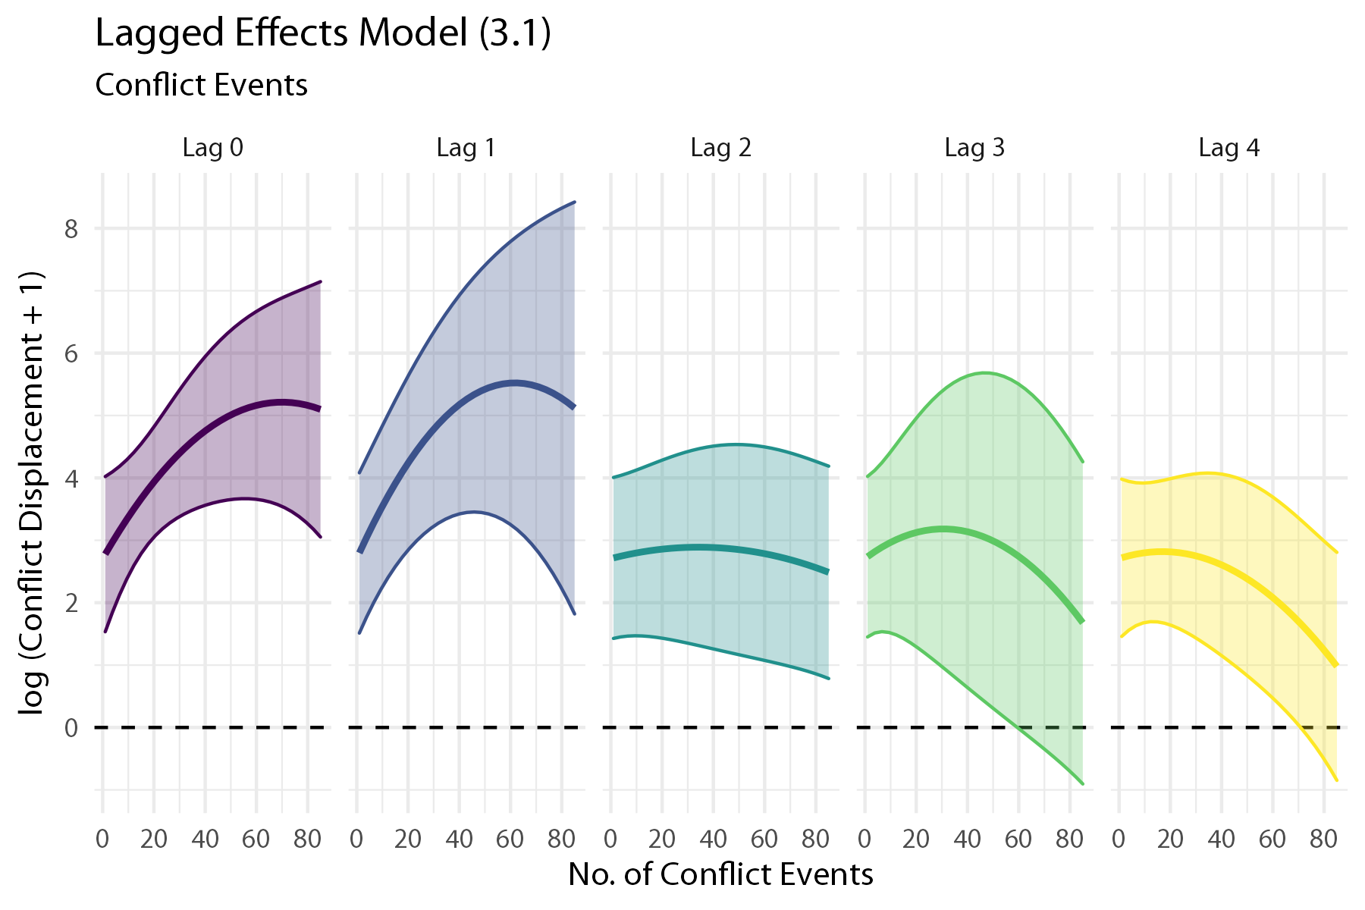

*Figure SPM 3.1.5: Lagged effects of conflict events on internal displacement over 1 to 4 months for Model 3.1.*

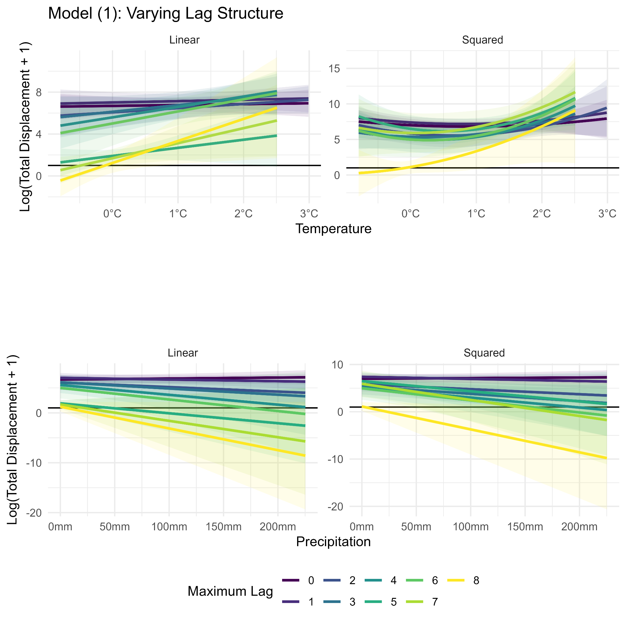

*Figure SPM 3.1.6: Sensitivity tests for varying lagged effects of absolute temperature and precipitation anomalies on internal displacement for Model 1.*

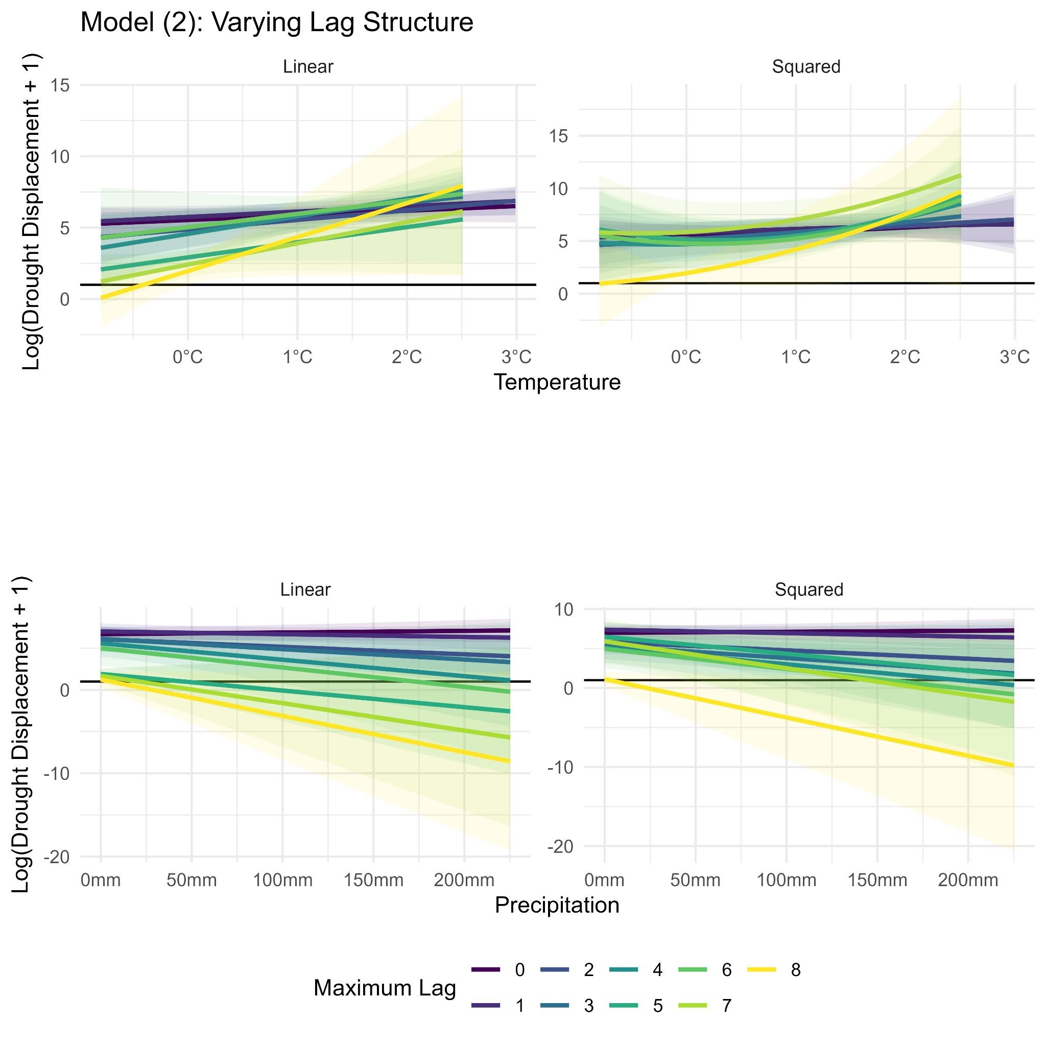

*Figure SPM 3.1.7: Sensitivity tests for varying lagged effects of absolute temperature and precipitation anomalies on internal displacement for Model 2.*

**SPM 3.2 Linear Model Specification**

Here we re-estimate all models reported in the main text, albeit restricting the model specification to linear terms (quadratic terms of temperatures, precipitation, and conflict are omitted).

The results from the linear models show similarly signed marginal effects as most of the quadratic specifications, however, in many cases the quadratic models are preferred due to the statistical significance of the non-linear terms.

*SPM 3.2.1 Weather Effects on Displacement*

Figures SPM 3.2.1 and SPM 3.2.2 show the linear effects of temperatures and precipitation on total displacement and drought-induced displacement respectively.

|  |
| --- |
|  |
| *SPM 3.2.1 Estimated cumulative linear effects of temperature (left) and precipitation anomalies (right) on total displacement from estimated Model 1.* |

|  |
| --- |
|  |
| *SPM 3.2.2 Estimated cumulative linear effect of temperature anomalies (left) and precipitation anomalies (right) on drought-reported displacement from Model 2* |

*SPM 3.2.2 Conflict Effects on Displacement*

Figure SPM3.2.3 and SPM3.2.4 show the linear effects of the number of conflict events on total displacement and conflict-induced displacement. Figure SPM3.2.3 does not control for weather while Figure SPM3.2.4 includes weather controls.

|  |  |
| --- | --- |
|  |  |
| *Figure SPM 3.2.3: Cumulative linear effect of conflict events on total displacement and conflict displacement. Histogram of conflict events over the sample shown in lower panel.* | |

|  |  |
| --- | --- |
|  |  |
| *Figure SPM 3.2.4: Cumulative linear effect of conflict events on total displacement and conflict displacement controlling for weather. Histogram of conflict events over the sample shown in lower panel.* | |

*SPM 3.2.3 Displacement Effects on Conflict*

Figure SPM3.2.5 shows the linear effect of arriving IDPs on the number of conflict events at the destination region without (left) and with (right) weather controls. While the point estimates are positive, the IDP coefficients are not statistically different from zero at the 1% level.

|  |  |
| --- | --- |
|  |  |
| *Figure SPM 3.2.5: Cumulative linear effect of arriving displaced people on the conflict events without (left) and with (right) controlling for weather.* | |

# SPM 4: Additional Results on Potential Endogeneity in Conflict-Displacement Models

There are two specific sources of potential endogeneity in our analysis of the effect of displacement on conflict. First, there may be conflict spillover effects where neighboring regions experience conflict at the same time, which might then be spuriously attributed to IDPs moving into a region. Second, there may be concerns around reverse causality, with IDPs moving to low-conflict regions.

We propose two remedies for these concerns. To address the first source, we restrict the models to only incoming IDPs that report drought as the reason for displacement. The resulting estimates are shown in Figures SPM 4.1 for drought-reported displacement only. Note that the estimate suggests a negative relationship for the level of most observed incoming IDPs, and a positive relationship likely driven by a small set of outlying large displacement events.

This specification also does not address the concerns around reverse-causality, which we tackle using our second remedy by restricting our models to include lagged independent variables only, i.e., not to use contemporaneous displacement. These lagged results are shown below in Figure SPM 4.2 for using one to four month lags on total displacement and Figure SPM 4.3 for using two to four month lags.

We also estimate models that combine both remedies. We estimate this for models with one to four lags (Figure SPM 4.4) and for a model with two to four lags, which we also present in the main text in Figure 6, right panel.

|  |
| --- |
|  |
| *Figure SPM 4.1: Cumulative effect of arriving drought-displaced people on conflict events.* |

|  |
| --- |
|  |
| *Figure SPM 4.2: Cumulative effect of arriving displaced people on conflict events using only one to four month lags in the independent variable.* |

|  |
| --- |
|  |
| *Figure SPM 4.3: Cumulative effect of arriving displaced people on conflict events using only two to four month lags in the independent variable.* |

|  |
| --- |
|  |
| *Figure SPM 4.4: Cumulative effect of arriving drought displaced people on conflict events using only one to four month lags in the independent variable.* |

To address an additional concern of endogeneity, we run dynamic models controlling for the lagged level of conflict in the destination region (i.e., Autoregressive Models). This way, we can test if past conflict influences the choice of destination areas, see Figures SPM 4.5 – SPM 4.8. We run four different model specifications: we run models with either lagged total displacement (B6.1 and B6.2) and with lagged drought displacement (B7.1 and B7.2). The models with number BX.1 are run with AR1 and the models BX.2 are run with AR1 through to AR4. The additional model results for these models are contained in Table SPM 4.

*Table SPM 4: Additional Endogeneity Model Results*

|  |  |  |  |  |
| --- | --- | --- | --- | --- |
|  | **B6.1** | **B6.2** | **B7.1** | **B7.2** |
| ar1.Conflict Events | 0.18746*** | 0.16667*** | 0.18864*** | 0.16823*** |
|  | (0.04664) | (0.04633) | (0.04378) | (0.04472) |
| L1.de.displacement | −0.000007 | −0.000008 |  |  |
|  | (0.000007) | (0.000007) |  |  |
| L2.de.displacement | 6e−08 | −0.000001 |  |  |
|  | (0.000005) | (0.000005) |  |  |
| L3.de.displacement | 0.00001 | 0.00001+ |  |  |
|  | (0.000006) | (0.000006) |  |  |
| L4.de.displacement | 0.000003 | 0.000003 |  |  |
|  | (0.000006) | (0.000006) |  |  |
| L1.de.displacement^2 | 1e−10 | 1e−10 |  |  |
|  | (8e−11) | (8e−11) |  |  |
| L2.de.displacement^2 | 6e−12 | 2e−11 |  |  |
|  | (5e−11) | (5e−11) |  |  |
| L3.de.displacement^2 | −1e−10 | −1e−10 |  |  |
|  | (7e−11) | (7e−11) |  |  |
| L4.de.displacement^2 | −4e−11 | −5e−11 |  |  |
|  | (8e−11) | (8e−11) |  |  |
| ar2.Conflict Events |  | 0.11145* |  | 0.10908* |
|  |  | (0.05341) |  | (0.05317) |
| ar3.Conflict Events |  | 0.02315 |  | 0.02898 |
|  |  | (0.04126) |  | (0.04059) |
| ar4.Conflict Events |  | −0.08481* |  | −0.08225* |
|  |  | (0.03429) |  | (0.03627) |
| L1.de.drought |  |  | −0.000009 | −0.00001 |
|  |  |  | (0.000008) | (0.000009) |
| L2.de.drought |  |  | −0.000002 | −0.000002 |
|  |  |  | (0.000006) | (0.000007) |
| L3.de.drought |  |  | 0.00001 | 0.00001 |
|  |  |  | (0.000009) | (0.000009) |
| L4.de.drought |  |  | −0.000003 | −0.000003 |
|  |  |  | (0.000006) | (0.000006) |
| L1.de.drought^2 |  |  | 2e−10 | 2e−10 |
|  |  |  | (1e−10) | (1e−10) |
| L2.de.drought^2 |  |  | −8e−12 | −2e−11 |
|  |  |  | (1e−10) | (1e−10) |
| L3.de.drought^2 |  |  | −1e−10 | −2e−10 |
|  |  |  | (1e−10) | (1e−10) |
| L4.de.drought^2 |  |  | −8e−12 | 5e−12 |
|  |  |  | (1e−10) | (1e−10) |
| Num.Obs. | 514 | 514 | 514 | 514 |
| R2 | 0.971 | 0.971 | 0.971 | 0.971 |
| R2 Adj. | 0.967 | 0.968 | 0.967 | 0.968 |
| AIC | 678.5 | 674.8 | 677.6 | 674.2 |
| BIC | 920.3 | 929.3 | 919.4 | 928.7 |
| RMSE | 0.42 | 0.42 | 0.42 | 0.41 |
| Std.Errors | by: region | by: region | by: region | by: region |
| S.E. Type | Cluster-robust | Cluster-robust | Cluster-robust | Cluster-robust |
| Fixed Effects | Year & Region | Year & Region | Year & Region | Year & Region |
| + p < 0.1, * p < 0.05, ** p < 0.01, *** p < 0.001 |  |  |  |  |

|  |
| --- |
|  |
| *Figure SPM 4.5: Cumulative effect of arriving total displacement on conflict events at the destination with AR1.* |

|  |
| --- |
|  |
| *Figure SPM 4.6: Cumulative effect of arriving total displacement on conflict events at the destination with AR1 to AR4 terms.* |

|  |
| --- |
|  |
| *Figure SPM 4.7: Cumulative effect of arriving drought displaced people on conflict events at the destination with AR1.* |

|  |
| --- |
|  |
| *Figure SPM 4.8: Cumulative effect of arriving drought displaced people on conflict events at the destination using AR1 through to AR4.* |

# 

# SPM 5: Additional Results on Conflict-Displacement Models

To test the sensitivity of our conflict-related models, we also consider an alternative measure for conflict - rather than counting the number of conflict events occurring, we now consider a variable representing the number of fatalities in a month that occur in any particular region. The results of these models are presented below (Figure SPM 5, panels A-H).

|  |  |
| --- | --- |
| **A.** Modified Model 3.1 with Fatalities instead of Conflict Events | **B.** Modified Model 3.2 with Fatalities instead of Conflict Events |
| **C.** Modified Model 3.2 with Fatalities instead of Conflict Events, where Fatalities have been transformed into a 0/1 dummy depending on whether the number of fatalities is greater or equal than 50 | **D.** Modified Model 3.2 with Fatalities instead of Conflict Events, where Fatalities have been transformed into a threshold dummy where the number of fatalities is 0 below 50 and the original value for any observations with more than or equal to 50 fatalities |
| **E.** Modified Model 4.1 with Fatalities instead of Conflict Events | **F.** Modified Model 4.2 with Fatalities instead of Conflict Events |
| **G.** Modified Model 5.1 with Fatalities instead of Conflict Events | **H.** Modified Model 5.2 with Fatalities instead of Conflict Events |

*Figure SPM 5: Additional figures on the relationship between conflict fatalities and displacement.*

# 

# SPM 6: Additional Results on Fixed Effect Specification

When illustrating our estimation results, we have chosen to show the predicted effect over the data range. This approach has been taken in all plots presented in the main text as well as in the sections SPM 2-6.

However, it is relevant to point out that in order to show a predicted effect for a two-way fixed effect panel estimator, a choice must be made regarding the fixed effect (FE) pairing to predict the effect for. In other words, when we predict the effect of e.g., extreme weather on displacement, we need to choose a baseline region and time that we predict our effects for.

In all plots presented, we have chosen to predict the effect for May 2016 - the first available FE when using four lags - in the region of Bakool. Using a different combination of FEs for the prediction produces an identical set of predictions in terms of the predicted shape of the relationship, yet each prediction pair will produce a different absolute magnitude prediction. This effect can indeed be quite large, as we illustrate for Model (1) below (Figure SPM 6.1).

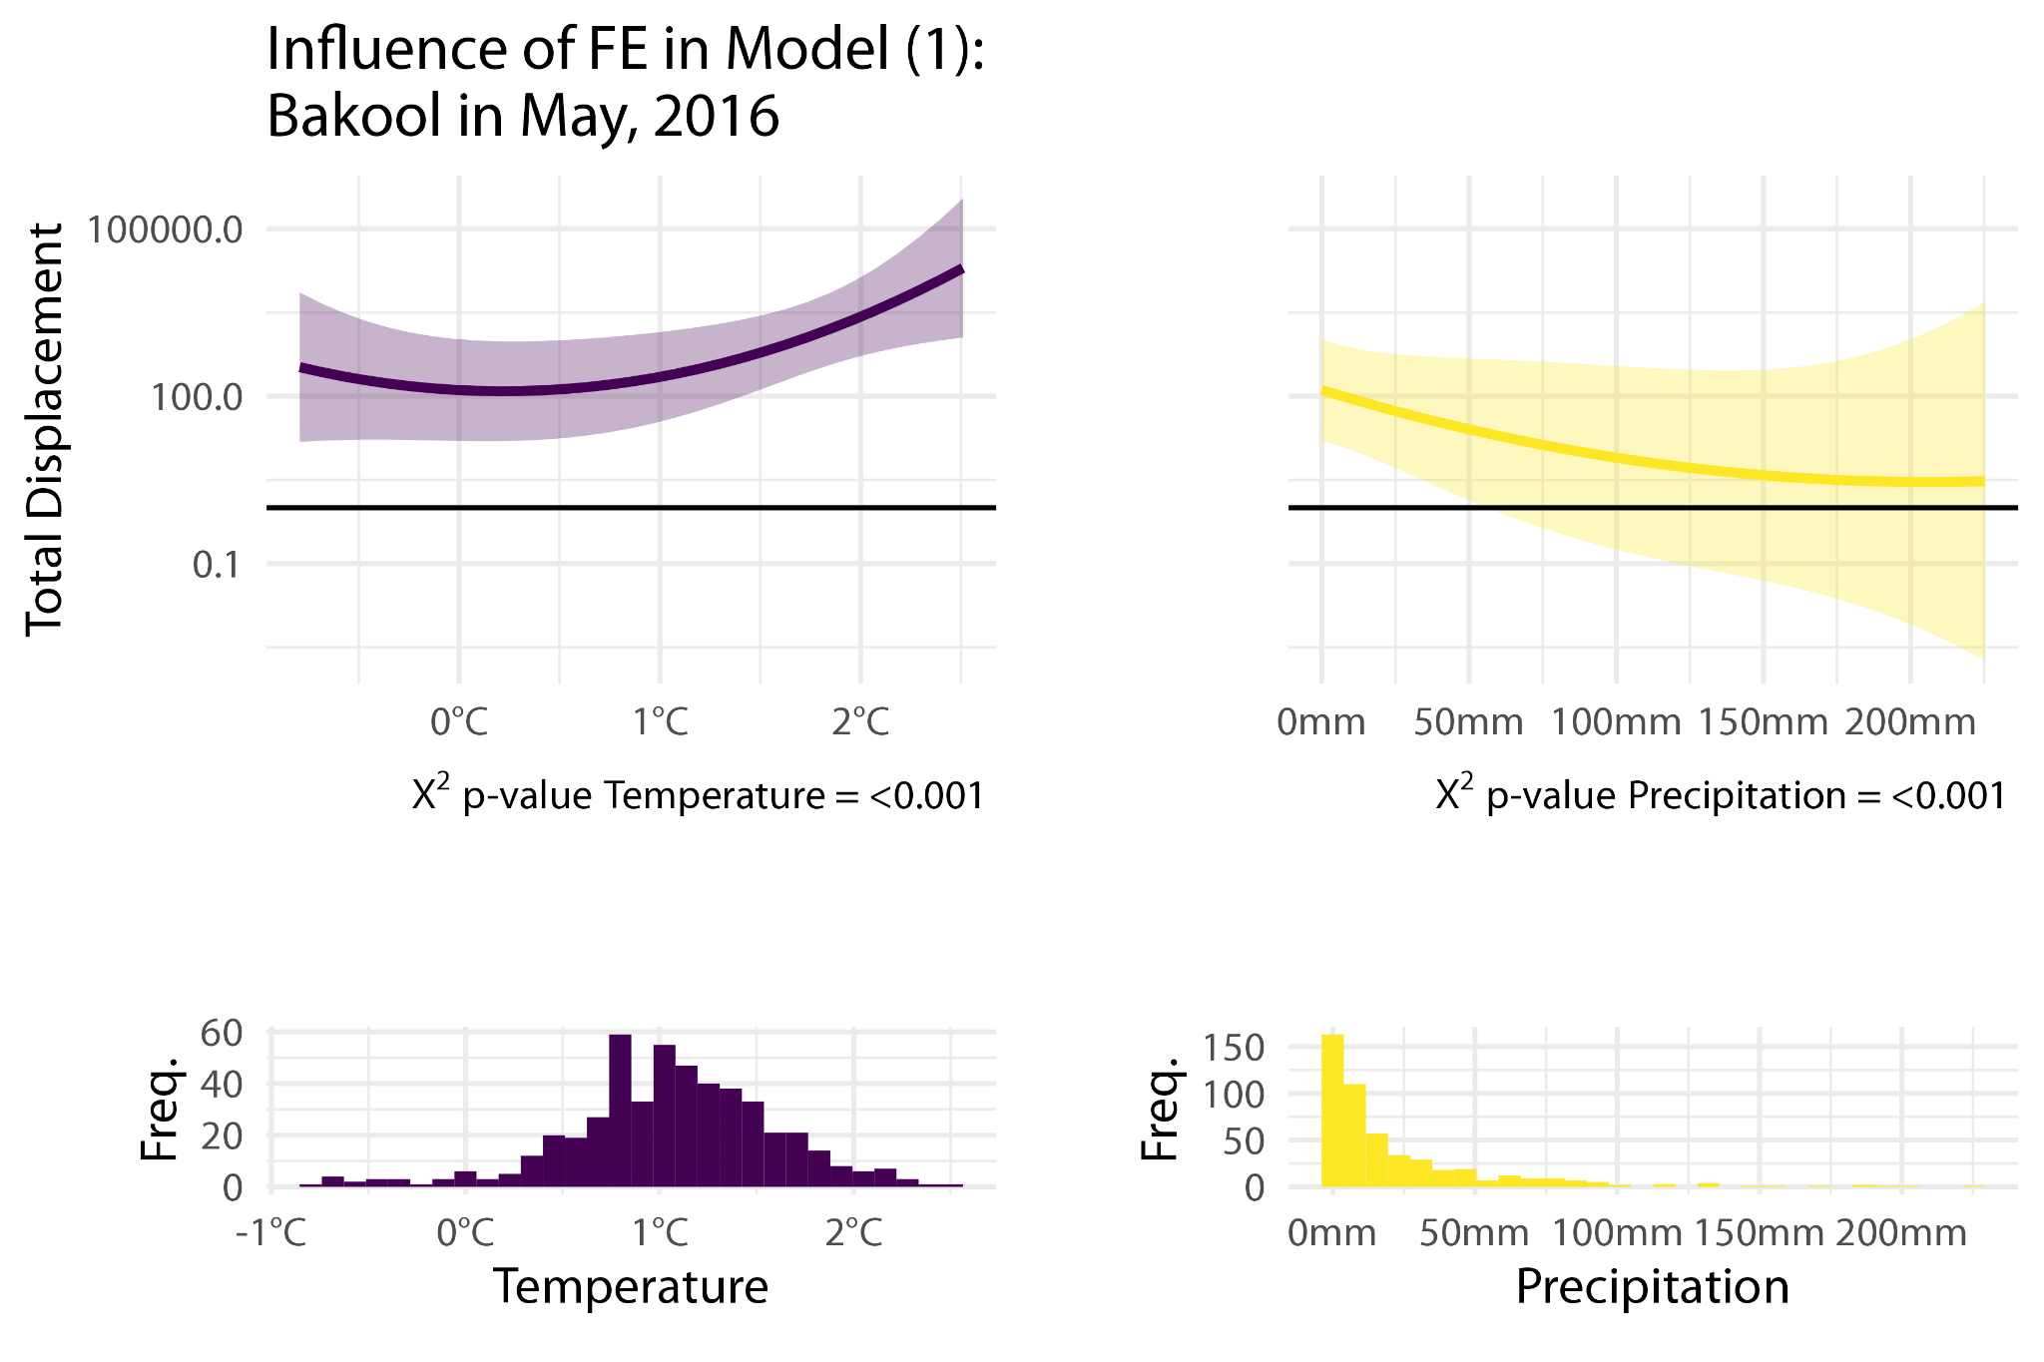

*Figure SPM 6.1: Identical Figure as in the main text - prediction of Model 1 in Bakool in May 2016.*

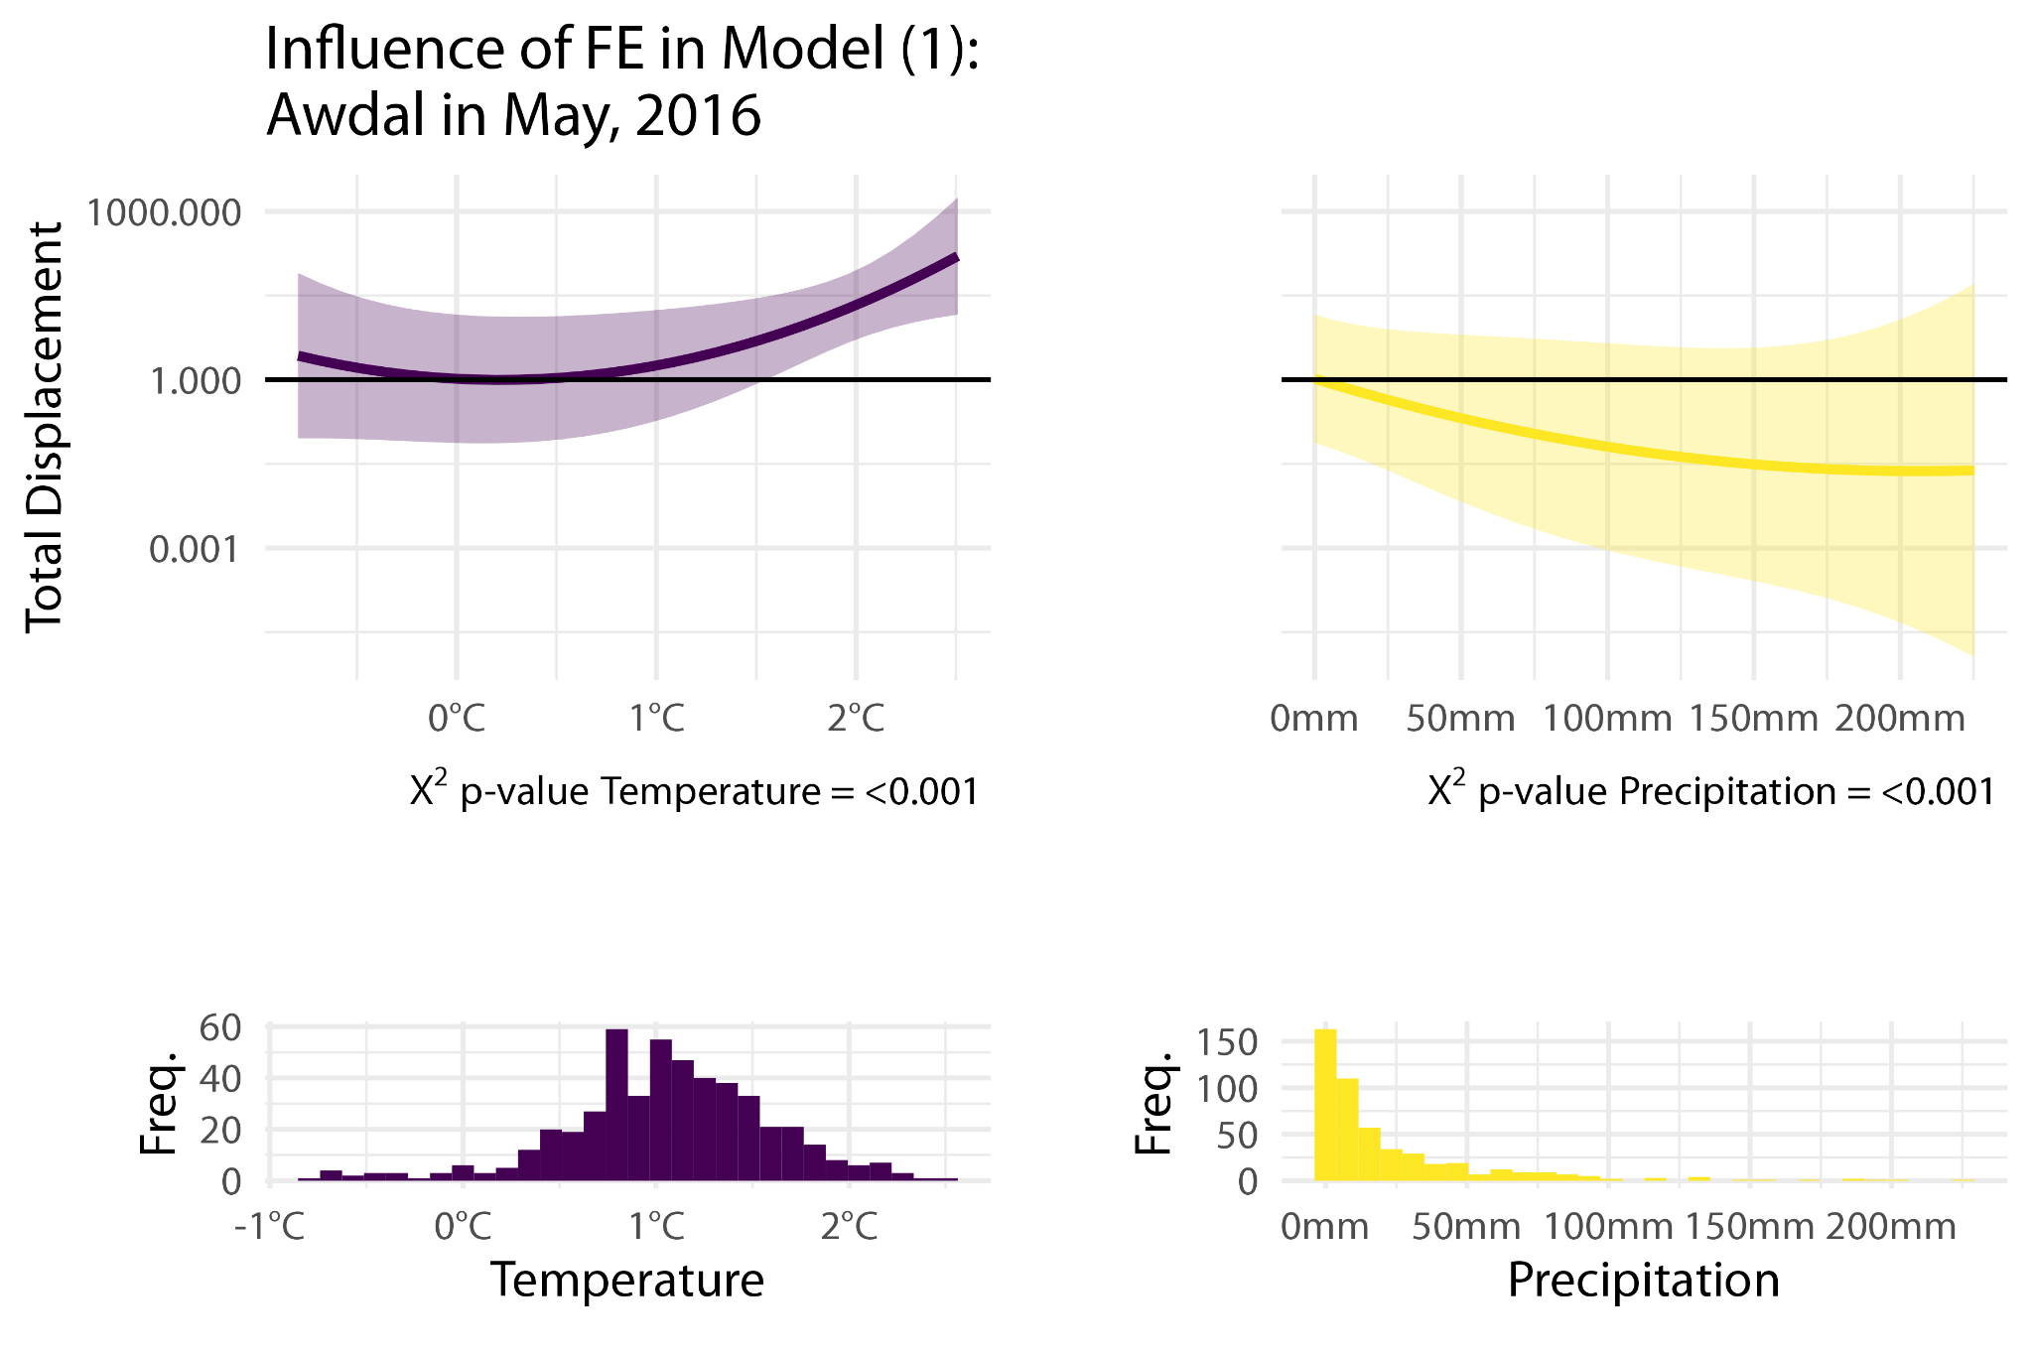

*Figure SPM 6.2: Prediction of Model 1 in Awdal in May 2016 producing the smallest overall predictions for temperature displacement.*

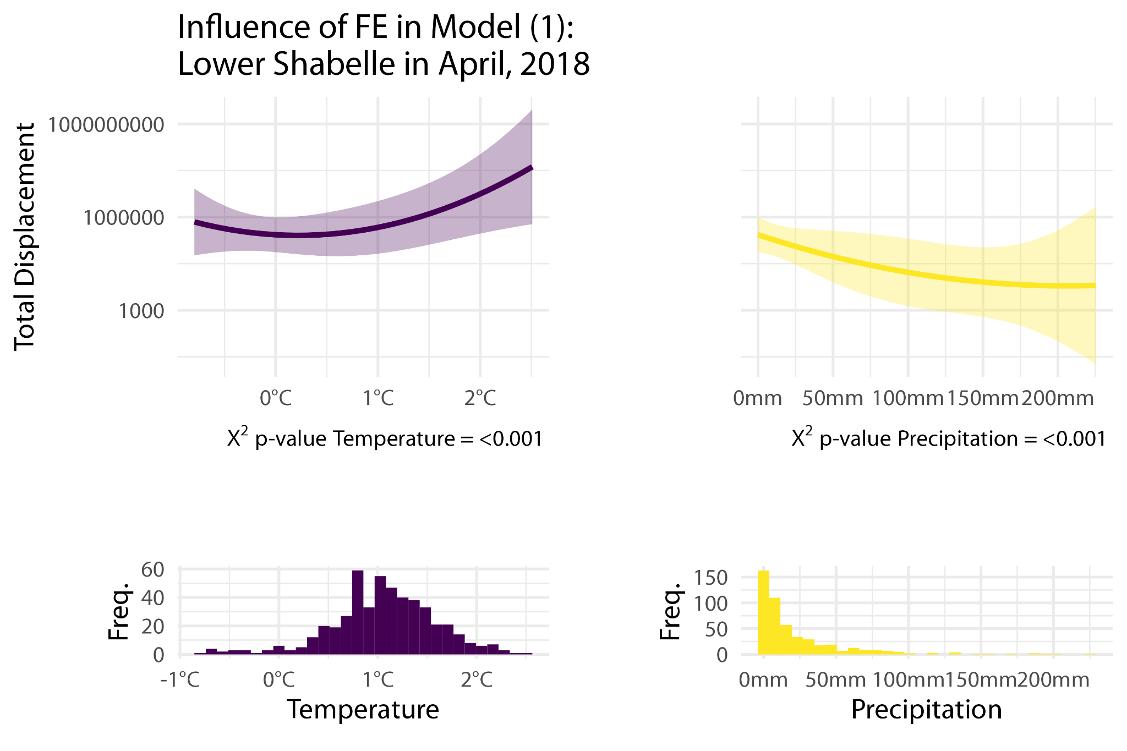

*Figure SPM 6.3: Prediction of Model 1 in Lower Shabelle in April 2018 producing the largest overall predictions for temperature displacement*

# SPM 7: Additional Results on conflict and drought-related interactions

Here we provide five additional models with conflict (B1) or drought displacement (B2 to B5) as the dependent variable. In doing so, we test if there is a displacement reduction in times of conflict by running interaction models that include both the weather and conflict variables and an interaction term between the two. Such interaction models allow us to test if drought and conflict have an independent effect on displacement, or if mobility is affected if the two stressors co-occur, see Figures SPM 7.1 to SPM 7.5 for an illustration of these results and the model estimation results models in Table SPM 7. In the following models, the interaction is formed between a dummy variable that indicates whether an observation displays a greater number of conflict events than the median level and either continuous precipitation (B2 and B3) or a dummy variable for precipitation where a positive value indicates precipitation greater than the median precipitation (B1). We also present additional models for drought displacement that contain the continuous conflict events variable (B4) or the conflict dummy, described above (B5).

*Table SPM 7: Interaction Model Results*

|  |  |  |  |  |  |
| --- | --- | --- | --- | --- | --- |
|  | **B1**  **Conflict D** | **B2**  **Drought D** | **B3**  **Drought D** | **B4**  **Drought D** | **B5**  **Drought D** |
| Temperature | 0.05560 | 0.18142 | 0.15544 | 0.16594 | 0.20039 |
|  | (0.36400) | (0.31516) | (0.30494) | (0.31130) | (0.32106) |
| Precipitation | 0.00124 | −0.00431 | −0.00517 | −0.00553 | −0.00504 |
|  | (0.00447) | (0.00421) | (0.00400) | (0.00388) | (0.00407) |
| Conflict Events | 0.03756* |  | −0.01041 | −0.01069 |  |
|  | (0.01574) |  | (0.01249) | (0.01282) |  |
| Dummy Conflict Events x Dummy Precipitation | 0.13838 |  |  |  |  |
|  | (0.11671) |  |  |  |  |
| L1.Temperature | 0.25183 | −0.15908 | −0.18123 | −0.11611 | −0.10992 |
|  | (0.37822) | (0.16033) | (0.16351) | (0.17540) | (0.17506) |
| L1.Precipitation | 0.00438 | −0.00740*** | −0.00776*** | −0.00710** | −0.00678** |
|  | (0.00531) | (0.00218) | (0.00211) | (0.00218) | (0.00223) |
| L1.Conflict Events | 0.04130 |  | −0.00592 | −0.00539 |  |
|  | (0.02860) |  | (0.00915) | (0.00936) |  |
| L1.Dummy Conflict Events x Dummy Precipitation | 0.12580+ |  |  |  |  |
|  | (0.06916) |  |  |  |  |
| L2.Temperature | 0.32785 | 0.39436+ | 0.39965+ | 0.41166+ | 0.40147+ |
|  | (0.38656) | (0.22157) | (0.22553) | (0.22974) | (0.21801) |
| L2.Precipitation | 0.00366 | −0.00431 | −0.00497 | −0.00477 | −0.00454 |
|  | (0.00535) | (0.00358) | (0.00338) | (0.00322) | (0.00315) |
| L2.Conflict Events | −0.00482 |  | −0.00191 | −0.00231 |  |
|  | (0.01012) |  | (0.00787) | (0.00766) |  |
| L2.Dummy Conflict Events x Dummy Precipitation | 0.09308 |  |  |  |  |
|  | (0.12879) |  |  |  |  |
| L3.Temperature | 0.12281 | 0.23984 | 0.23135 | 0.20830 | 0.20343 |
|  | (0.55823) | (0.20226) | (0.20639) | (0.20298) | (0.18751) |
| L3.Precipitation | 0.00523 | −0.00391+ | −0.00448+ | −0.00318 | −0.00335 |
|  | (0.00459) | (0.00211) | (0.00237) | (0.00231) | (0.00214) |
| L3.Conflict Events | 0.00208 |  | −0.00486 | −0.00367 |  |
|  | (0.02523) |  | (0.00739) | (0.00727) |  |
| L3.Dummy Conflict Events x Dummy Precipitation | 0.14133 |  |  |  |  |
|  | (0.09126) |  |  |  |  |
| L4.Temperature | 0.24628 | 0.53428* | 0.54146* | 0.51742* | 0.54668* |
|  | (0.45339) | (0.23811) | (0.24876) | (0.23358) | (0.23222) |
| L4.Precipitation | 0.00582 | −0.00376 | −0.00422+ | −0.00375 | −0.00379 |
|  | (0.00436) | (0.00257) | (0.00253) | (0.00295) | (0.00307) |
| L4.Conflict Events | −0.01793 |  | −0.00267 | −0.00337 |  |
|  | (0.01313) |  | (0.00933) | (0.00994) |  |
| L4.Dummy Conflict Events x Dummy Precipitation | −0.02567 |  |  |  |  |
|  | (0.09378) |  |  |  |  |
| Dummy Conflict Events X Precipitation |  | −0.03362 | −0.03459 |  |  |
|  |  | (0.06665) | (0.07269) |  |  |
| L1.Dummy Conflict Events X Precipitation |  | −0.03566 | −0.03164 |  |  |
|  |  | (0.05209) | (0.05148) |  |  |
| L2.Dummy Conflict Events x Precipitation |  | 0.09952* | 0.10193* |  |  |
|  |  | (0.04060) | (0.04251) |  |  |
| L3.Dummy Conflict Events x Precipitation |  | −0.04021 | −0.04078 |  |  |
|  |  | (0.05629) | (0.05827) |  |  |
| L4.Dummy Conflict Events x Precipitation |  | 0.10098+ | 0.10153+ |  |  |
|  |  | (0.05932) | (0.06141) |  |  |
| Dummy Conflict Events |  |  |  |  | 0.05851 |
|  |  |  |  |  | (0.34292) |
| L1.Dummy Conflict Events |  |  |  |  | −0.09464 |
|  |  |  |  |  | (0.22827) |
| L2.Dummy Conflict Events |  |  |  |  | −0.02701 |
|  |  |  |  |  | (0.16500) |
| L3.Dummy Conflict Events |  |  |  |  | −0.14772 |
|  |  |  |  |  | (0.24064) |
| L4.Dummy Conflict Events |  |  |  |  | −0.37339+ |
|  |  |  |  |  | (0.19236) |
| Num.Obs. | 496 | 496 | 496 | 496 | 496 |
| R2 | 0.814 | 0.959 | 0.959 | 0.959 | 0.959 |
| R2 Adj. | 0.785 | 0.953 | 0.953 | 0.953 | 0.953 |
| AIC | 2212.3 | 1755.9 | 1763.2 | 1758.9 | 1755.8 |
| BIC | 2494.2 | 2016.7 | 2045.1 | 2019.7 | 2016.6 |
| RMSE | 1.97 | 1.25 | 1.25 | 1.26 | 1.25 |
| Std.Errors | by: region | by: region | by: region | by: region | by: region |
| S.E. Type | Cluster-robust | Cluster-robust | Cluster-robust | Cluster-robust | Cluster-robust |
| Fixed Effects | Year & Region | Year & Region | Year & Region | Year & Region | Year & Region |
| + p < 0.1, * p < 0.05, ** p < 0.01, *** p < 0.001 |  |  |  |  |  |

|  |
| --- |
|  |
| *Figure SPM 7.1: Cumulative effect on conflict displacement including the interaction effect between a precipitation dummy and a conflict dummy.* |

|  |
| --- |
|  |
| *Figure SPM 7.2: Cumulative effect on drought displacement with an interaction term between continuous precipitation and a conflict dummy..* |

|  |
| --- |
|  |
| *Figure SPM 7.3: Cumulative effect using an interaction term between continuous precipitation and a conflict dummy.* |

|  |
| --- |
|  |
| *Figure SPM 7.4: Cumulative effect on drought displacement, controlling for two temperature, precipitation, and conflict events.* |

|  |
| --- |
|  |
| *Figure SPM 7.5: Cumulative effects on drought displacement, controlling for weather variables and a conflict dummy.* |